The city

Overvuew:

So the city is all powered with ( inoput here ) nio pixel LEDs .

( insert pic )

They are all in sections with conectores under eatch city ( please note these are not keyed take care when seting up a city) ( insert pic ) there is a master doc with where all the LEDs are located for the current lay out the document is ( insert name ).

This is powered from a PSU outputing 5 volts onput of the laser cutter this hase to power rails one ( in use ) for all the leds on the wall and any futer LEds , and a second witch is for use with any motors we use in future all to be contoled by the master PCB located also on top of the laser cutter in the black box.

( insert pics )

The wall is controled from this PCB with a ( insert name here ) arduino the pin out is below

The LEds are current on **pin D18**

( insert pin out )

This bored has a lot of outputs and is basted on the esp32 wifi chip.

City contrustion :

The city is formed of moduler secgtions that can be changed out or repeard away from the wall they are all made out of laser cut wood and are formed of two main section . the front pannel and the back pannel ( as seen apndix 1&2) the back pannel houses all the LEDS apart from blade runner where a section is on the froint pannel there are cenectors to unplug be take care. ( pic ) the front pannel is held on by magnets to the back pannel and can be removed easy with the one exsetption of the blade runner. If you need to replace a cable going between a city these are held in the ground just befow the city the front pannel just pops off and the cables are inside.

Apendix :

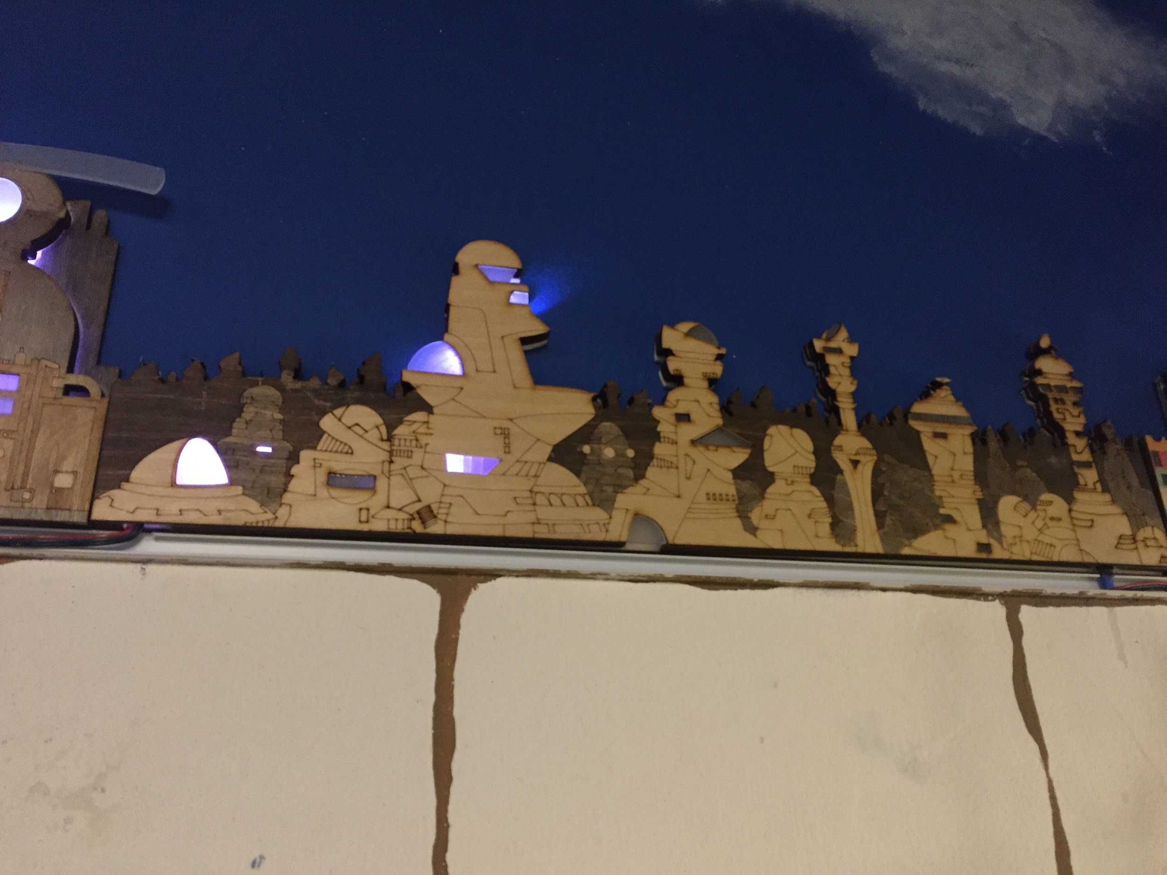( apendix 1)

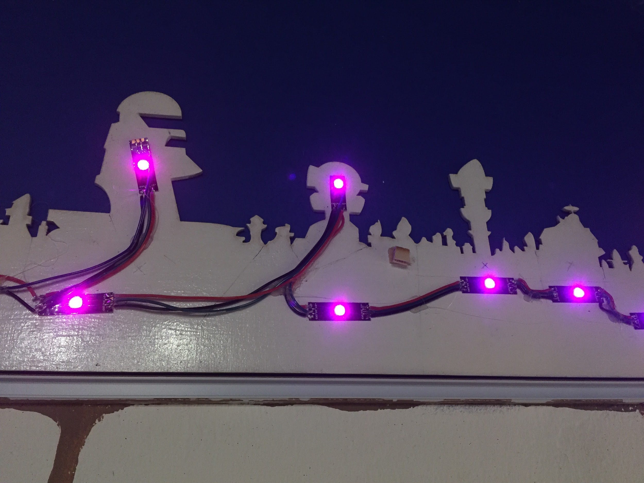( apedix 2)

Nio pixel conectors:

Arduino :

The arduino Is a DOIT Esp32 DevKit v1 arduino and can be coded through the arduino ide .

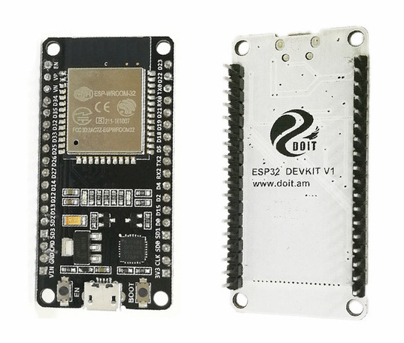

We are using pin D18 for the neo pixels on the city ( more pixels and pins might follow)

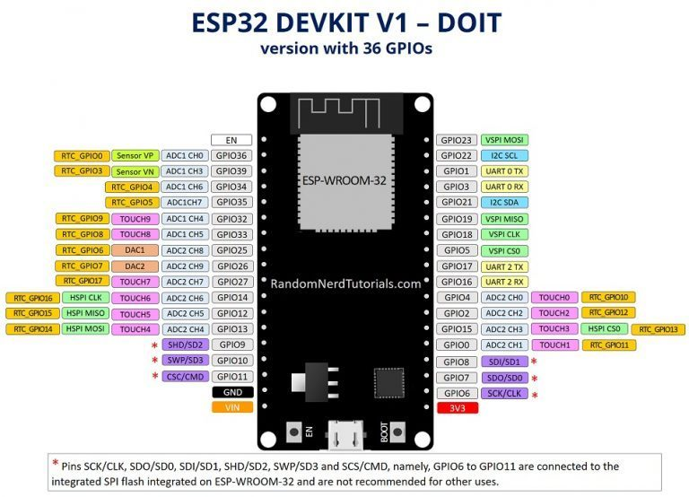

( i beleave the pic above is the wright board need to cheack )

this arduino while useful is not as straightforward to set us as normal ones.

I had to install the board manually as the it didn't appear to show in the normal libary

The instructions on how to install the board on your relevant operating system can be found at the below link

<https://github.com/espressif/arduino-esp32/tree/master/docs/arduino-ide>

Apendix :

<https://docs.zerynth.com/latest/official/board.zerynth.doit_esp32/docs/index.html>